Lab 6.1 Commands & Args in YAML

- Create a pod-definition.yml file as below:
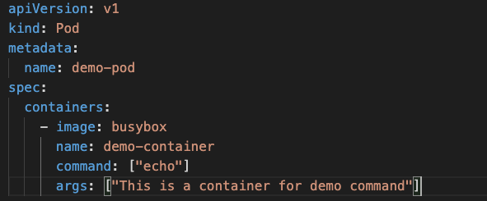

- Create the Pod
kubectl create -f pod-definition.yml

- Check the Logs in the Pod
kubectl logs -f demo-pod

- Since this is a short running workload, kubernetes thinks that the app has crashed and will attempt to restart it. Keep observing the pod status and notice the Number of Restarts
kubectl get pods

- To prevent the restarts, set the restart policy in pod-definition.yml
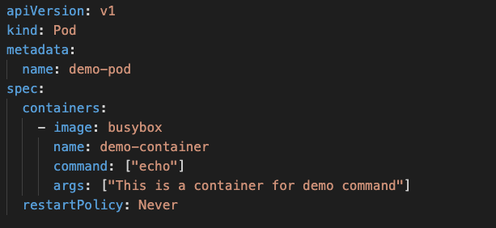

- Delete the pod
kubectl delete pod/demo-pod

- Recreate and notice the number of restarts
kubectl create -f pod-definition.yml

